**Title:** The Potential Effect of Ending CDC Funding for HIV Tests: A Modeling Study in 18 States

**Authors:**

1. Ruchita Balasubramanian, MPhil

Harvard T.H. Chan School of Public Health

[rbalasubramanian@g.harvard.edu](mailto:rbalasubramanian@g.harvard.edu)

1. Melissa Schnure, PhD ScM

Johns Hopkins University School of Medicine

mschnur2@jhmi.edu

1. Ryan Forster, PhD

Johns Hopkins Bloomberg School of Public Health

rforste3@jhmi.edu

1. William P. Hanage, PhD,

Harvard T. H. Chan School of Public Health

whanage@hsph.harvard.edu

1. D. Scott Batey, PhD MSW

Tulane School of Social Work

dsbatey@tulane.edu

1. Keri N. Althoff, PhD MPH

Johns Hopkins Bloomberg School of Public Health

kalthoff@jhu.edu

1. Kelly A. Gebo, MD MPH

Johns Hopkins University School of Medicine

kgebo@jhmi.edu

1. David W. Dowdy, MD PhD

Johns Hopkins Bloomberg School of Public Health

ddowdy1@jhmi.edu

1. Maunank Shah, MD PhD

Johns Hopkins University School of Medicine

mshah28@jhmi.edu

1. Parastu Kasaie, PhD MS

Johns Hopkins Bloomberg School of Public Health

pkasaie@jhu.edu

1. Anthony T. Fojo, MD MHS

Johns Hopkins University School of Medicine

Anthony.Fojo@jhmi.edu

**Grant Support:** R01MD018539

**Abstract:**

**Background:**

Timely diagnosis and treatment of HIV is critical to preventing transmission. The US Centers for Disease Control and Prevention (CDC) provides funding for HIV testing to local health departments and community organizations. We sought to estimate the number of additional HIV infections that would result from ending or interrupting CDC funding for HIV tests in US states.

**Methods:**

We used a validated model of HIV transmission to simulate HIV epidemics in 18 US states. We projected incidence forward under three scenarios where all CDC-funded HIV testing ends in October 2025 and (1) never resumes, (2) returns to previous levels between January and December 2029, and (3) resumes from January to December 2027. We calculated the excess incident HIV infections compared to a scenario where CDC-funded testing continues uninterrupted.

**Results:**

If CDC funding for HIV tests ends in the 2026 budget year, we project 12,751 additional HIV infections across the 18 states by 2030 (95% credible interval 4,548 to 21,906) across all 18 states – an increase of 10%. The projected effects varied by state, ranging from a 2.7% increase in Washington (1.0 to 4.7%) to a 29.8% increase in Louisiana (9.4 to 59.8%). In general, states that perform more CDC funded tests and states with more rural HIV epidemics were projected to see greater rises in incidence.

If funding resumes in 2029, we project 8,563 (3,125 to 14,412) excess HIV infections, an increase of 8.1%. If funding resumes in 2027, we project 4,051 (1,568 to 6,528) additional infections, 3.9% more.

**Conclusions:**

Disruptions to CDC-funded HIV testing would substantially increase new infections, particularly in states with more rural epidemics. These findings demonstrate the value of the CDC’s HIV testing activities in curbing the spread of HIV in the US.

**Introduction**:

HIV imposes a substantial health burden in the US, with over one million prevalent cases as of 20231. Timely diagnosis and treatment of HIV is critical to preventing transmission1,2–4. People with HIV who are virally suppressed on antiretroviral therapy are non-infectious. Even before treatment, people with HIV reduce behaviors associated with transmission once they are aware of their status5,6.

The US Centers for Disease Control and Prevention (CDC) provides funding for HIV testing to state and local health departments, as well as community-based organizations7. In 2021, CDC funding supported 1,736,850 tests, resulting in 8,149 new HIV diagnoses8. While CDC’s testing data are not directly comparable to its surveillance data, this is a little more than one-fifth the 35,763 total diagnoses recorded in the US in 2021. In some states, this ratio is much higher: approximately 1/2 of diagnoses in South Carolina and Alabama, and 6/10 in Tennessee.

In general, HIV testing is an efficient means of HIV prevention. CDC-funded tests are particularly efficient, and disproportionally used in demographic subgroups with high rates of HIV infection7. However the White House’s 2026 budget proposal eliminates the CDC’s HIV Prevention Program, which supports most of CDC’s HIV testing activities9.

Disruptions to CDC-funded HIV testing could have a major impact on HIV incidence in the US10. Mathematical models can be a useful tool to help forecast the impacts of HIV-related health policy11,12. We used a validated model of HIV transmission in the US to project the potential impact of the cessation or interruption of CDC-funded HIV testing on state-level HIV-epidemics.

**Methods:**

Model Structure:

The Johns Hopkins Epidemiologic and Economic Model (JHEEM) is a validated, dynamic, compartmental model of HIV transmission that has been calibrated to cities and states in the US, and is stratified by age, sex, race/ethnicity, and risk-status for HIV acquisition11.

To represent the impact of CDC-funded HIV testing, we expanded JHEEM to simulate, for each demographic stratum, (1) the proportion of HIV tests that are funded by the CDC and (2) the proportion of new diagnoses that are made by CDC-funded HIV tests. These proportions were each modeled using a logistic equation, parameterized with terms for age, race, sex, risk factor, and time (see Supplement).

Study Setting:

We simulated HIV epidemics in 18 states: Alabama, Arizona, California, Florida, Georgia, Illinois, Kentucky, Louisiana, Maryland, Missouri, Mississippi, Ohio, New York, South Carolina, Tennessee, Texas, Washington, and Wisconsin. These states were chosen for geographic distribution and balance of urban/rural composition, mix of Medicaid expansion status, and prioritization in the *Ending the HIV Epidemic* initiative.

Model Calibration:

JHEEM’s calibration has been described previously; briefly, we ran an Adaptive Metropolis Sampler for 1,000,000 iterations in each city, and retained a set of 1,000 well-fitting simulations. These simulations reproduce local epidemiological measures of the epidemic, including new diagnoses, prevalent cases, and proportion of the general population who report being tested for HIV during the preceding year.

For each of the 1,000 base JHEEM simulations per state, we ran another Adaptive Metropolis Sampler for 300 iterations to calibrate the parameters for the logistic models for the proportion of HIV tests funded by CDC and the positivity among CDC-funded HIV tests. We derived prior distributions based on national data and formulated a likelihood for two calibration targets drawn from annual CDC HIV Testing reports from 2011 to 2019: (1) the number of CDC-funded tests in each state and (2) the rate of positivity (excluding known cases) among CDC-funded tests (see Supplement)13.

Modeled Scenarios

In addition to a scenario where CDC funding for HIV tests continues uninterrupted, we simulated three scenarios (Figure 1): (1) “Cessation” - CDC funding for HIV tests stops on October 1, 2025, and CDC-funded tests linearly decline to zero by December 31, 2025; (2) “Brief Interruption” - CDC funding for tests stops as in “Cessation,” but funding resumes on January 1, 2027 and testing returns to prior levels by December 31, 2027; (3) “Prolonged Interruption” - CDC funding for tests stops in October 2025, and testing returns to prior levels from January 1, 2029 to December 31, 2029 (see Supplement)

In the absence of CDC funding, presumably some individuals who would have gotten an HIV test funded by the CDC would get tested by other means, such as private insurance or an ER visit. However, this proportion is not well characterized: no studies to our knowledge have examined the withdrawal of public funding for HIV tests. The CDC did publish an evaluation of the roll-out of a program to distribute HIV self-tests: of the 206,637 people who took one or more tests and responded to a survey, 52% had not been tested in the past year14.

To quantify this uncertainty, each of the 1,000 simulations per city sampled a different value of a parameter representing “the proportion of CDC-funded tests that would be obtained regardless.” We sampled these values from a Beta distribution with a mean of 50% based on the CDC’s self test program results . Because this study offers only a rough approximation of what might happen if CDC funding for HIV tests stops, our samples had a wide 95% confidence interval spanning 20% to 80%.

Outcomes:

Our primary outcome was the projected relative excess incident HIV infections from 2025 to 2030:

$$\frac{HIV {Incidence}_{intervention}-HIV {Incidence}_{baseline}}{HIV Incidence_{baseline}}$$

Secondary outcomes included (a) the absolute number of excess HIV infections from 2025 to 2030 and (b) the number of CDC-funded tests not performed for each excess infection. For each outcome in each state, we calculated the mean across 1,000 simulations and the 95% credible interval (the 2.5th to 97.5th percentile).

Secondary Analyses:

To evaluate potential determinants of state-level variation, we calculated Spearman correlation coefficients between the in the relative projected excess incident HIV infections from 2025 to 2030 and five possible determinants (averaged for each state across simulations): (1) the proportion of HIV tests in 2025 that were funded by the CDC; (2) the proportion of HIV diagnoses in 2025 that were made with CDC-funded tests; (3) the proportion of prevalent HIV cases in 2025 that were virally suppressed; and (4) the transmission rate of HIV in 2025; and (e) the “urbanicity” of each state’s HIV epidemic in 2021, which we defined as the number of prevalent cases of HIV in each county multiplied by the proportion of people in that county living in urban areas (per the 2020 census) divided by the total number of prevalent cases in the state15. Because we modeled only 18 states, we calculated a univariate correlation with each determinant separately. We visualized these relationships using scatterplots.

Sensitivity Analyses:

To assess the sensitivity of our results to influential parameters, we calculated the partial rank correlation coefficients in each state for the 35 parameters governing either (a) the proportion of HIV tests funded by the CDC or (b) the proportion of diagnoses made with CDC-funded tests. We assessed the impact of each parameter by calculating the primary outcome among the 200 simulations with the highest values of each parameter vs. the 200 simulations with the lowest values (see Supplement)16.

Web Tool:

All simulations are available through our interactive web tool at www.jheem.org/cdc-testing.

**Results:**

Our simulations closely matched the number of CDC-funded HIV tests and positivity rate by state (see Supplement). If CDC funding for tests continues uninterrupted, our model projected incident infections from 2025 to 2030 across all 18 states (129,252 95% CrI 123,738 to 136,034).

If CDC-funded testing ends permanently in 2025 (“Cessation”) our model projected 12,751 excess HIV infections across the 18 states (95% CrI: 4,548 to 21,906) - an increase of 9.9% (3.6 to 16.9%) vs. if testing continues. This impact varied substantially by state, ranging from a 2.7% increase in Washington (1.0 to 4.7%) to a 29.8% increase in Louisiana (9.4 to 59.8%) - illustrated in Figures 1, 2, and 3 and online at www.jheem.org/cdc-testing.

If CDC funding for tests is restored in 2029 and testing returns to prior levels by the end of that year (“Prolonged Interruption”), our model projected 10,630 (3,866 - 17,925) excess HIV infections, an increase of 8.2% (3.0 to 14.0%). If CDC-funded testing returns in 2027, the model projected 5,027 (1,942 to 8,066) excess infections, an increase of 3.9% (1.5 to 6.3%).

We projected that the increases in incidence would accrue more to young adults - 13% (5 to 22%) increase among 13-34 year olds vs. 6% (2 to 11%) among those over 35. Excess infections would also be higher among men who have sex with men - 11% (4 to 20%) - and heterosexual men - 9% (3 to 16%) - than among women - 7% (3 to 12%). We did not project large differences by race: 11% (4 to 19%) for Black adults, 9% (3 to 15%) for Hispanic adults, and 9% (3 to 16%) for non-Black, non-Hispanic adults.

In assessing potential determinants of between-state differences the in-state proportion of diagnoses made by CDC-funded tests had the highest correlation (0.90) with the impact of ending CDC funding for HIV tests and with the proportion of the state’s HIV tests that were funded by the CDC (0.30). The impact was also negatively correlated (-0.14) with the “urbanicity” of states’ HIV epidemics: the more a state’s epidemic was situated in rural areas, the greater the impact of removing CDC funding for HIV tests (see Figure 4).

Across all states, we projected that 9.9 million HIV tests would not be done from 2025 to 2030 in the “Cessation” scenario. This meant that every 911 tests not funded by the CDC would incur one excess infection between 2025 and 2030 in the “Cessation” scenario (95% CrI 452 to 2,142) tests. The efficiency of CDC-funded tests varied between states, ranging from 137 (63 to 327) tests per excess infection in Ohio to 4,310 (2,157 to 9,978) in Maryland (see Figure 5).

In our sensitivity analysis, the most influential parameter by far was the proportion of CDC-funded tests that would be done otherwise if CDC funding ends, with a partial rank correlation coefficient less than -0.99 in all states (see Supplement). Across all states, the 200 simulations where only 11 to 36% of tests would still be obtained projected 1,067 excess cases between 2025 and 2030 (300 to 1,664). Conversely, the 200 simulations where 63 to 88% of tests would still be obtained projected 368 (94 to 511) excess infections if all CDC-funded HIV testing was permanently ceased (Figure 6).

**Discussion:**

We used a mathematical HIV transmission model to estimate the impact of disruptions to CDC funding for HIV tests in 18 US states. Across all states, we project that complete cessation of CDC-funded HIV testing would lead to 12,751 additional HIV infections from 2025 to 2030 (95% CrI 4,548 to 21,906) or an increase of 10% (4 to 17%). Temporary interruptions to testing would also result in substantially more infections: an 8% increase if testing resumes in 2029 (3 to 14%) and a 4% increase (2 to 6%) if testing resumes in 2027. The projected number of excess infections varied between states, reaching as high as 30% (9 to 60%) in Louisiana.

Differences between states were most closely correlated with the number of tests funded by the CDC and the proportion of a state’s diagnoses that were made with CDC-funded tests. The impact of ending CDC funding for HIV tests was also correlated with the urban/rural distribution of HIV in the state: states with a more rural epidemic tended to have higher projected increases in incidence from disruptions to CDC-funded testing.

Our projections depended on the degree to which people would still seek out HIV tests if CDC-funded tests are not available. If less than one-third get tested anyway, we project 1,064 excess infections vs. 368 if more than two-thirds still get tested (under complete cessation of CDC-funded HIV testing). The true proportion of people who would still get tested is unknown; there are no studies to our knowledge on the effects of widespread reductions in public HIV testing. We incorporated this uncertainty into our analysis by sampling a range of possible values across the 1,000 simulations in each state. To inform our sampling range, we looked at an evaluation of the CDC’s self-HIV testing program, and presumed that the proportion of self-test clients who had not been tested in the year preceding the program (52%) would approximate the fraction who would not be tested if the program ceased14. However, not getting a test before a program exists may not equate to not getting one after it goes away, and the population using self-tests may not reflect the broader population served by all CDC testing (most of which is delivered in healthcare and community settings). We therefore sampled a broad range around a mean of 50% of CDC tests being performed regardless: 95% of simulations had a value from 20 to 80%.

Some “back-of-the-envelope” calculations lend support to this range. In 2019, 26% of CDC-funded tests were performed in non-healthcare settings, 47% were done at sexually-transmitted disease clinics, correctional facilities, and community health centers, and the remaining 27% were performed in ERs, hospitals, primary care clinics, and other healthcare settings. If we presume that tests in healthcare settings would mostly still be performed, while those outside would not, 74% could be considered a high-end estimate of how many tests would be done regardless. Conversely, if we assume that only tests in traditional healthcare settings like ERs and primary care clinics would still be done, we might consider 27% to be a low-end estimate. Fundamentally, this quantity is uncertain, and our analysis reflects this uncertainty in broad credible intervals around our projections. The importance of this parameter implies that if CDC funding for HIV tests does end, efforts to mobilize access to other means of HIV testing will be critical to mitigate the impact on local HIV epidemics.

There are few other published estimates of the impact of the CDC’s HIV testing activities. Hutchinson et al. used a transmission model to estimate that CDC-funded HIV tests averted 3,381 new infections nationwide from 2007 to 2009, during which 2.8 million people were tested (824 people tested per infection averted)17. This is lower than the 12,000 infections averted over five years in 18 states that we project, although similar to our aggregate 921 tests per infection averted. Our model differs from Hutchinson et al. in that it is dynamic - those who are infected can in turn infect others, who can infect others, and so on - whereas Hutchinson et al. calculated infections averted as a difference in transmission rate multiplied by the number of people diagnosed for each of the three years. More recently, the CDC estimated that HIV prevention programs (including both testing and other prevention programs) prevented 9,000 infections between 2017 and 2021 - again lower than our estimate, while not taking into account dynamic transmission effects18.

As with any modeling study, our approach has several limitations. First, we focused on incident infections only; however, delayed diagnosis of HIV may lead to increased morbidity and mortality. Second, we only model 18 US states. While the majority of HIV diagnoses in 2024 were made in these states, they may not reflect the full heterogeneity of HIV epidemics across the US. Third, in our interruption scenarios, we assume that CDC testing activities would return to their previous levels within a year, but it is possible that programs might recover more slowly or never come back online. Fourth, our projections assume no concurrent changes to HIV prevention and control efforts in the US. This is unlikely to be true; cessation of CDC-funded testing would likely be accompanied by other disruptions to prevention activities, and future changes to Medicaid coverage may impact HIV screening and care. However, the precise nature of such disruptions is harder to quantify, and limiting the model to CDC-funded testing allows us to isolate the impact of this specific aspect of HIV control. Last, our model does not distinguish between HIV tests funded by CDC’s HIV prevention programs, which are slated to be cut in the current White House 2026 budget proposal, and tests under the *Ending the HIV Epidemic* initiative, which are preserved9.

Our approach has several strengths. Using state-level models allows us to capture local-level heterogeneity in HIV epidemics and the particular ways they interact with testing funded by the CDC. Our Bayesian calibration process allows us to robustly recapitulate historical trends and characterize uncertainty in future projections. Finally, our projections are all available in an interactive web tool at jheem.org/cdc_testing, allowing local decision makers to consider the potential impact of changes to CDC testing programs in their setting.

In summary, using an HIV transmission model in 18 states, we found that even brief interruptions to CDC-funded HIV testing could lead to more than 5,000 excess HIV infections by 2030. Complete cessation of testing would lead to a projected 12,751 additional infections. These effects varied across states, with states that use more CDC-funded tests and states with more rural epidemics expected to see greater increases in transmission. These findings demonstrate the value of the CDC’s HIV testing activities in curbing the spread of HIV in the US.

**Figure 1. Projected HIV Infections in Illinois, Texas and Louisiana if CDC-funded HIV Testing is Disrupted**

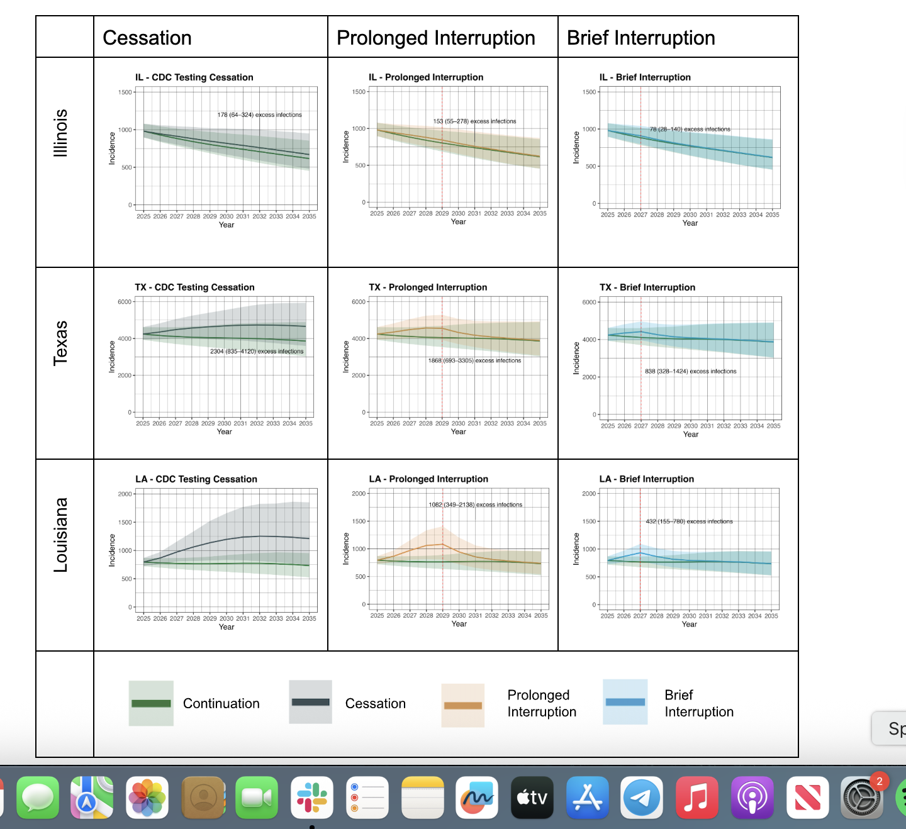

Sample projections for Illinois, Texas, and Louisiana. Y-axes give the projected number of infections. Lines denote the mean across 1,000 simulations; ribbons give the 95% credible interval. Green represents uninterrupted “Continuation” of CDC funding for HIV testing. In the other scenarios, funding stops in October 2025. In the “Cessation” scenario (navy blue), CDC-funded tests never resume. In “Prolonged Interruption” (orange), CDC-funded tests return to prior levels from January to December 2029. In “Brief Interruption” (blue), testing recovers from January to December 2027. Times of reintroduction of testing (2027 and 2029) are shown as vertical dashed red lines.

**Figure 2. Projected Excess HIV Infections if CDC-funded HIV Testing is Disrupted**

|  |  |  |  |  |  |  |  |
| --- | --- | --- | --- | --- | --- | --- | --- |
|  | **Continuation** | **Cessation** | | **Prolonged Interruption** | | **Brief Interruption** | |
| **State** | Number of  Incident Infections | Number of Excess Infections | Relative Excess Infections* | Number of Excess Infections | Relative Excess Infections* | Number of Excess Infections | Relative Excess Infections* |
| **Louisiana** | 4,639 | 1,388 | 29.8% | 1,082 | 23.3% | 432 | 9.3% |
| (3,896 - 5,397) | (429 - 2,823) | (9.4 - 59.8%) | (349 - 2,138) | (7.7 - 45.1%) | (155 - 780) | (3.5 - 16.3%) |
| **Missouri** | 2,886 | 624 | 21.5% | 513 | 17.7% | 228 | 7.9% |
| (2,461 - 3,289) | (187 - 1,261) | (6.7 - 42.8%) | (158 - 1,011) | (5.7 - 34.0%) | (78 - 410) | (2.8 - 13.9%) |
| **Mississippi** | 2,562 | 515 | 20.2% | 433 | 16.9% | 201 | 7.9% |
| (2,172 - 3,013) | (186 - 978) | (7.4 - 37.4%) | (160 - 802) | (6.2 - 30.7%) | (76 - 345) | (3.0 - 13.3%) |
| **South Carolina** | 3,136 | 532 | 17.0% | 450 | 14.4% | 217 | 6.9% |
| (2,730 - 3,529) | (176 - 1,016) | (5.8 - 31.1%) | (153 - 836) | (5.0 - 25.9%) | (82 - 382) | (2.6 - 11.8%) |
| **Tennessee** | 5,348 | 883 | 16.5% | 722 | 13.5% | 323 | 6.1% |
| (4,390 - 6,463) | (289 - 1,652) | (5.6 - 30.4%) | (244 - 1,330) | (4.6 - 24.2%) | (119 - 557) | (2.3 - 10.5%) |
| **Alabama** | 3,915 | 595 | 15.2% | 494 | 12.6% | 226 | 5.8% |
| (3,408 - 4,371) | (194 - 1,120) | (5.1 - 28.1%) | (167 - 915) | (4.4 - 22.8%) | (83 - 397) | (2.2 - 9.9%) |
| **Arizona** | 3,855 | 474 | 12.3% | 382 | 9.9% | 173 | 4.5% |
| (3,259 - 4,539) | (161 - 904) | (4.1 - 22.8%) | (134 - 715) | (3.3 - 17.9%) | (65 - 300) | (1.6 - 7.5%) |
| **Georgia** | 12,271 | 1,316 | 10.7% | 1,144 | 9.3% | 587 | 4.8% |
| (10,760 - 14,479) | (466 - 2,301) | (3.9 - 18.1%) | (412 - 1,994) | (3.4 - 15.6%) | (220 - 995) | (1.8 - 7.7%) |
| **Texas** | 24,654 | 2,304 | 9.4% | 1,868 | 7.6% | 838 | 3.4% |
| (21,675 - 28,703) | (835 - 4,120) | (3.4 - 16.1%) | (693 - 3,305) | (2.8 - 13.0%) | (328 - 1,424) | (1.3 - 5.7%) |
| **California** | 16,832 | 1,444 | 8.5% | 1,245 | 7.4% | 633 | 3.7% |
| (14,542 - 19,692) | (486 - 2,648) | (3.0 - 15.3%) | (424 - 2,273) | (2.7 - 12.9%) | (226 - 1,105) | (1.4 - 6.3%) |
| **Ohio** | 4,373 | 354 | 8.1% | 300 | 6.9% | 146 | 3.4% |
| (3,668 - 5,219) | (126 - 646) | (3.0 - 14.5%) | (108 - 541) | (2.5 - 12.2%) | (56 - 254) | (1.3 - 5.7%) |
| **Florida** | 19,839 | 1,331 | 6.7% | 1,140 | 5.7% | 581 | 2.9% |
| (17,442 - 22,844) | (484 - 2,407) | (2.4 - 11.4%) | (418 - 2,037) | (2.1 - 9.7%) | (223 - 998) | (1.1 - 4.8%) |
| **New York** | 10,753 | 508 | 4.7% | 435 | 4.0% | 218 | 2.0% |
| (9,173 - 12,407) | (180 - 920) | (1.7 - 8.2%) | (155 - 788) | (1.5 - 7.0%) | (79 - 390) | (0.7 - 3.5%) |
| **Wisconsin** | 1,468 | 64 | 4.3% | 55 | 3.8% | 28 | 1.9% |
| (1,170 - 1,802) | (23 - 119) | (1.5 - 8.1%) | (20 - 103) | (1.4 - 7.0%) | (11 - 52) | (0.7 - 3.5%) |
| **Kentucky** | 1,365 | 55 | 4.0% | 48 | 3.5% | 26 | 1.9% |
| (1,153 - 1,662) | (19 - 106) | (1.4 - 7.0%) | (16 - 92) | (1.2 - 6.2%) | (9 - 49) | (0.7 - 3.2%) |
| **Illinois** | 5,204 | 178 | 3.4% | 153 | 2.9% | 78 | 1.5% |
| (4,438 - 6,337) | (64 - 324) | (1.2 - 5.9%) | (55 - 278) | (1.1 - 5.1%) | (28 - 140) | (0.5 - 2.6%) |
| **Maryland** | 2,747 | 92 | 3.4% | 81 | 2.9% | 44 | 1.6% |
| (2,261 - 3,440) | (34 - 158) | (1.2 - 5.8%) | (30 - 137) | (1.1 - 5.1%) | (16 - 73) | (0.6 - 2.7%) |
| **Washington** | 3,404 | 92 | 2.7% | 83 | 2.4% | 47 | 1.4% |
| (2,815 - 3,983) | (34 - 157) | (1.0 - 4.7%) | (31 - 140) | (0.9 - 4.2%) | (18 - 78) | (0.5 - 2.3%) |
| **Total** | 129,252 | 12,751 | 9.9% | 10,630 | 8.2% | 5,027 | 3.9% |
| (123,738 - 136,034) | (4,548 - 21,906) | (3.6 - 16.9%) | (3,866 - 17,925) | (3.0 - 14.0%) | (1,942 - 8,066) | (1.5 - 6.3%) |
|  |  | |  |  |  | | --- | --- | --- | | 0% |  | 30% | | | | | | |

The “Continuation” column gives the mean and 95% credible interval, across 1,000 simulations, for projected incident HIV infections from 2025-2030 if CDC funding for HIV tests continues uninterrupted. The columns labeled “Number of Excess Infections” give the mean and 95% interval of the absolute number of excess HIV infections expected from 2025-2030 under three scenarios where funding is stopped in October 2025: “Cessation” (funding does not resume), “Prolonged Interruption” (testing returns to prior levels from January to December 2029), and “Brief Interruption” (testing recovers from January to December 2027). The columns labeled “Relative Excess Infections” give the percent change in projected incident infections, relative to “Continuation”. Cells are shaded according to the relative excess infections.

**Figure 3. Projected Excess HIV Infections if CDC-funded HIV Testing is Disrupted**

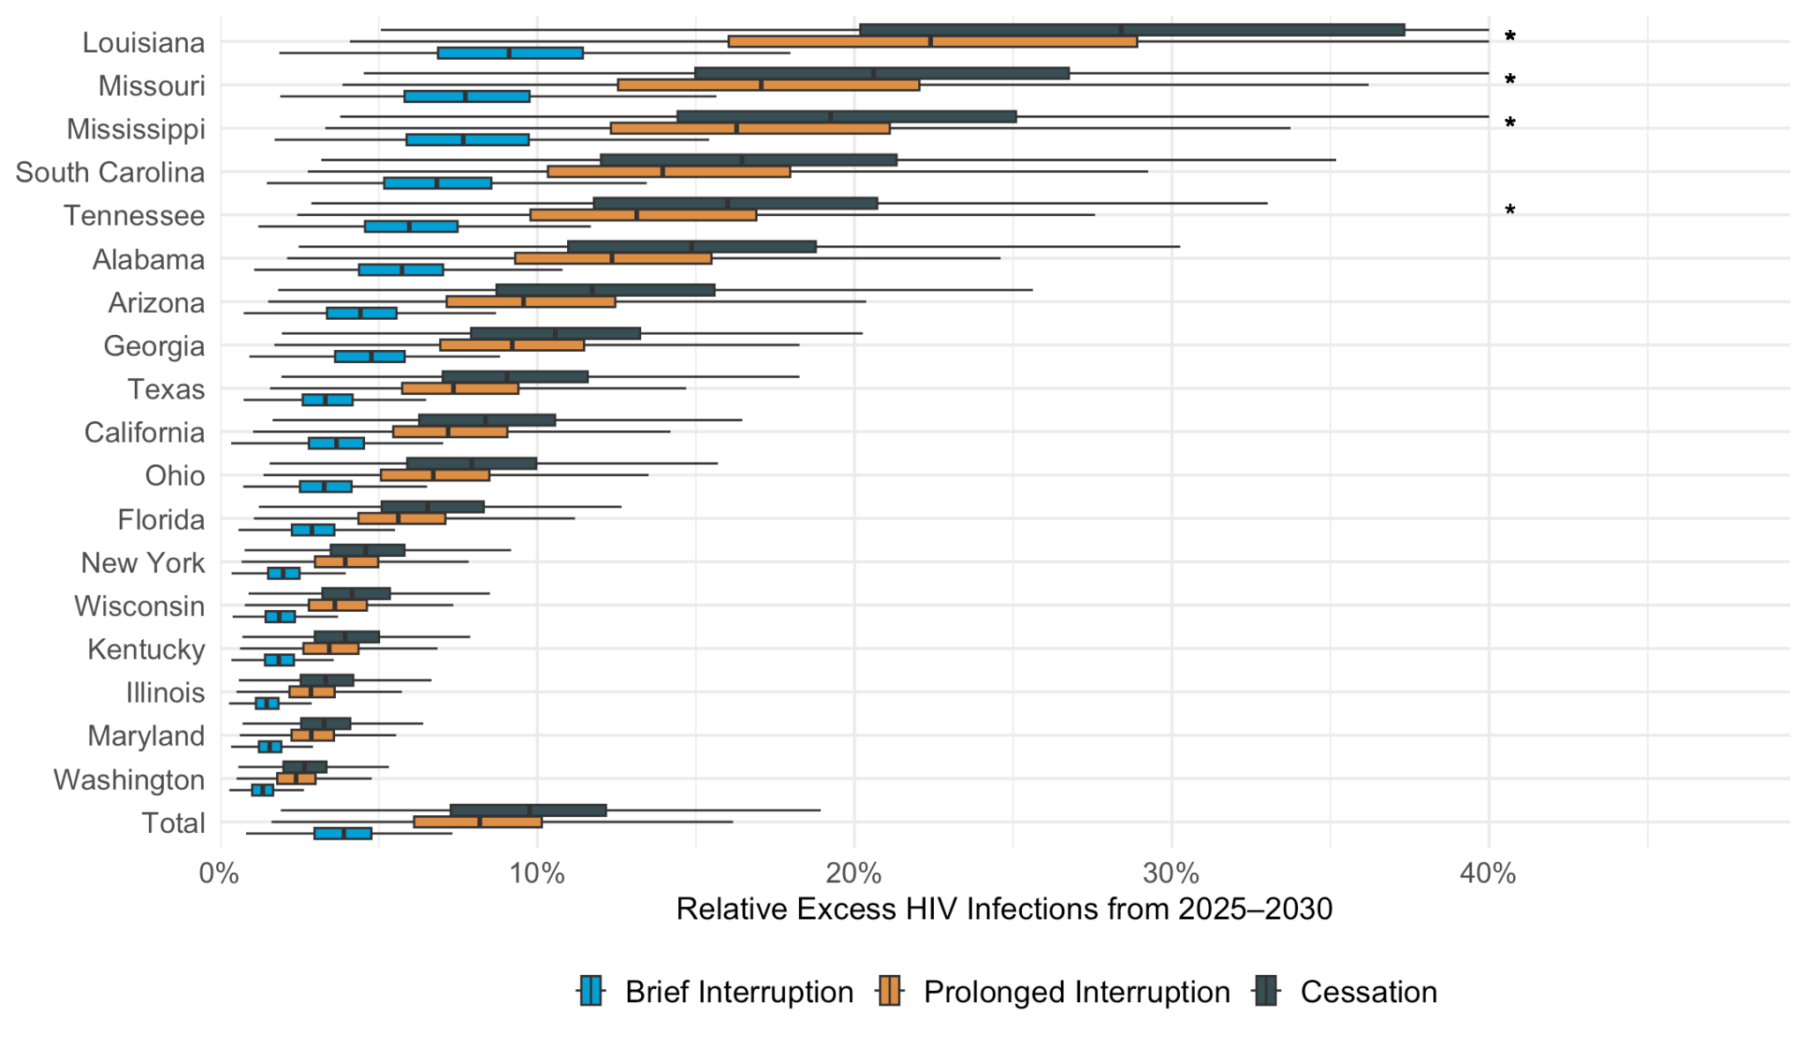

Boxplots display the projected percentage increase in new infections under three scenarios in which CDC funding for HIV testing ends in October 2025: “Cessation” (navy blue) – funding does not resume; “Prolonged Interruption” (orange) – testing returns to prior levels from January to December 2029; “Brief Interruption” (blue) – testing recovers from January to December 2027. The value along the x-axis represents the relative increase in cases vs. a scenario where CDC-funded HIV tests continue uninterrupted. The dark vertical lines indicate the mean projection across 1,000 simulations, the boxes indicate interquartile ranges (IQR), and whiskers cover the 95% credible interval. *The credible interval has been truncated at 40%.

**Figure 4. State-level Variation in Excess HIV Infections if CDC-funded HIV Testing Ends**

|  |  |
| --- | --- |
|  |  |
|  |  |
|  | |

Each circle represents one state. The y-axis represents the average relative increase in projected HIV infections from 2025 to 2030 if CDC funding for HIV testing ends in October 2025 vs. if it continues, averaged across 1,000 simulations. The x-axis represents the average proportion of 2025 diagnoses that were made with CDC-funded tests in the state (Panel A), the average proportion of all tests in 2025 that were funded by the CDC (Panel B), the average transmission rate in 2025 (Panel C), or the proportion of prevalent HIV cases in 2021 that fell into rural areas with the state (Panel D). The size of the circle is proportional to the number of projected new diagnoses in 2025. Cities are shaded according to the proportion of prevalent cases that fall into rural areas. Correlation denotes the Spearman correlation.

**Figure 5. Number of CDC-funded Tests Not Performed per Excess Infection**

|  |  |  |  |
| --- | --- | --- | --- |
| **State** | **Cessation** | **Prolonged Interruption** | **Brief Interruption** |
| **Ohio** | 137 | 125 | 129 |
| (63 - 327) | (59 - 296) | (64 - 294) |
| **Mississippi** | 310 | 274 | 281 |
| (139 - 712) | (126 - 625) | (139 - 621) |
| **New York** | 403 | 364 | 367 |
| (186 - 961) | (168 - 876) | (173 - 874) |
| **South Carolina** | 504 | 426 | 396 |
| (218 - 1,247) | (192 - 1,037) | (196 - 905) |
| **Missouri** | 630 | 541 | 535 |
| (250 - 1,632) | (228 - 1,379) | (251 - 1,289) |
| **Louisiana** | 632 | 552 | 577 |
| (246 - 1,593) | (226 - 1,355) | (270 - 1,321) |
| **Georgia** | 650 | 521 | 443 |
| (310 - 1,579) | (252 - 1,251) | (223 - 1,025) |
| **Tennessee** | 666 | 580 | 574 |
| (288 - 1,623) | (256 - 1,383) | (280 - 1,311) |
| **Florida** | 733 | 632 | 583 |
| (348 - 1,702) | (305 - 1,453) | (296 - 1,303) |
| **Alabama** | 751 | 633 | 604 |
| (322 - 1,857) | (281 - 1,540) | (295 - 1,405) |
| **Washington** | 767 | 608 | 490 |
| (390 - 1,745) | (310 - 1,389) | (252 - 1,121) |
| **California** | 884 | 728 | 634 |
| (403 - 2,186) | (333 - 1,761) | (305 - 1,481) |
| **Wisconsin** | 1,458 | 1,173 | 1,011 |
| (646 - 3,376) | (526 - 2,692) | (470 - 2,298) |
| **Arizona** | 1,642 | 1,332 | 1,171 |
| (706 - 4,017) | (596 - 3,215) | (577 - 2,699) |
| **Texas** | 1,646 | 1,366 | 1,266 |
| (770 - 3,798) | (652 - 3,133) | (648 - 2,806) |
| **Kentucky** | 2,135 | 1,721 | 1,430 |
| (915 - 5,213) | (744 - 4,157) | (639 - 3,395) |
| **Illinois** | 2,823 | 2,291 | 1,962 |
| (1,260 - 6,592) | (1,047 - 5,353) | (911 - 4,537) |
| **Maryland** | 4,310 | 3,494 | 2,908 |
| (2,157 - 9,978) | (1,769 - 8,043) | (1,508 - 6,510) |
| **Total** | 911 | 759 | 697 |
| (452 - 2,142) | (386 - 1,761) | (379 - 1,568) |
|  |  |  |  |

Values denote the mean and 95% credible interval (across 1,000 simulations in each state) of the number of CDC-funded tests that would have been performed from 2025 to 2030 divided by the number of excess HIV infections that would result under three scenarios where funding is stopped in October 2025: “Cessation” (funding does not resume), “Prolonged Interruption” (testing returns to prior levels from January to December 2029), and “Brief Interruption” (testing recovers from January to December 2027). The columns labeled “Relative Excess Infections” give the percent change in projected incident infections, relative to “Continuation”. Cells are shaded according to the number of tests not done per excess infection incurred.

**Figure 6: Excess HIV Infections 2025-2030 if CDC Funding for HIV Tests Ends, depending on the Proportion of Tests Performed Regardless**

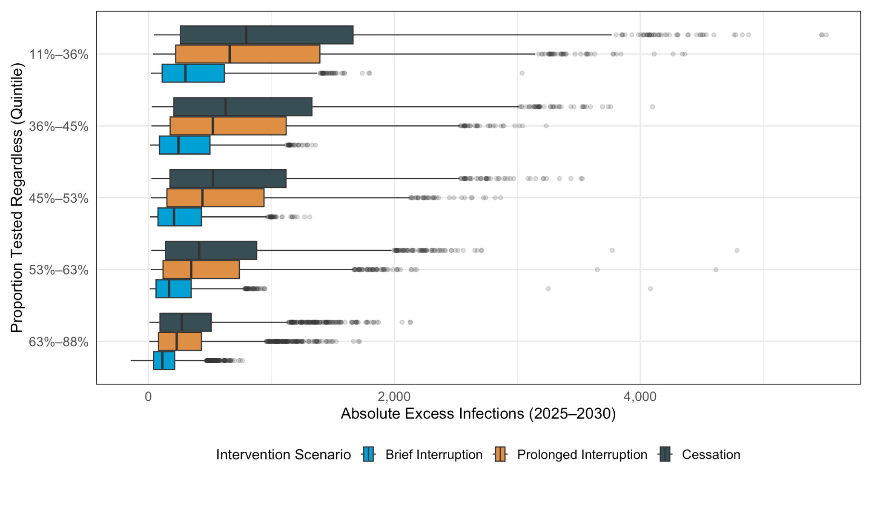

Boxplots display the projected percentage increase in new infections under stratified by the simulated proportion of people who would be tested regardless of whether CDC-funded tests are available. Colors denote: “Cessation” (navy blue) – funding does not resume; “Prolonged Interruption” (orange) – testing returns to prior levels from January to December 2029; “Brief Interruption” (blue) – testing recovers from January to December 2027. The value along the x-axis represents the relative increase in cases vs. a scenario where CDC-funded HIV tests continue uninterrupted. The dark vertical lines indicate the mean projection across 1,000 simulations, the boxes indicate interquartile ranges (IQR), and whiskers cover the 95% credible interval. *The credible interval has been truncated at 40%.

**References**

1. CDC. HIV Diagnoses, Deaths, and Prevalence: 2025 Update. HIV Data. 2025; published online April 29. https://www.cdc.gov/hiv-data/nhss/hiv-diagnoses-deaths-and-prevalence-2025.html (accessed July 21, 2025).

2. Nosyk B, Fojo AT, Kasaie P, *et al.* The Testing Imperative: Why the US Ending the Human Immunodeficiency Virus (HIV) Epidemic Program Needs to Renew Efforts to Expand HIV Testing in Clinical and Community-Based Settings. *Clin Infect Dis* 2023; **76**: 2206–8.

3. Cohen MS, Chen YQ, McCauley M, *et al.* Antiretroviral Therapy for the Prevention of HIV-1 Transmission. *New England Journal of Medicine* 2016; **375**: 830–9.

4. Rodger AJ, Cambiano V, Bruun T, *et al.* Risk of HIV transmission through condomless sex in serodifferent gay couples with the HIV-positive partner taking suppressive antiretroviral therapy (PARTNER): final results of a multicentre, prospective, observational study. *Lancet* 2019; **393**: 2428–38.

5. Marks G, Crepaz N, Senterfitt JW, Janssen RS. Meta-analysis of high-risk sexual behavior in persons aware and unaware they are infected with HIV in the United States: implications for HIV prevention programs. *J Acquir Immune Defic Syndr* 2005; **39**: 446–53.

6. Marks G, Crepaz N, Janssen RS. Estimating sexual transmission of HIV from persons aware and unaware that they are infected with the virus in the USA. *AIDS* 2006; **20**: 1447–50.

7. Williams W, Krueger A, Wang G, Patel D, Belcher L. The Contribution of HIV Testing Funded by the Centers for Disease Control and Prevention to HIV Diagnoses in the United States, 2010–2017. *J Community Health* 2021; **46**: 832–41.

8. CDC-Funded HIV Testing in the United States, Puerto Rico, and U.S. Virgin Islands, 2021 Annual HIV Testing Report. https://stacks.cdc.gov/view/cdc/149067 (accessed July 21, 2025).

9. Technical Supplement to the 2026 Budget. https://www.whitehouse.gov/wp-content/uploads/2025/05/appendix_fy2026.pdf.

10.Trump Budget Ends All CDC HIV Prevention Programs, While Maintaining Care, Treatment, and PrEP | HIV+Hepatitis Policy Institute. https://hivhep.org/press-releases/trump-budget-ends-all-cdc-hiv-prevention-programs-while-maintaining-care-treatment-and-prep/ (accessed July 21, 2025).

11.Fojo AT, Schnure M, Kasaie P, Dowdy DW, Shah M. What Will It Take to End HIV in the United States? : A Comprehensive, Local-Level Modeling Study. *Ann Intern Med* 2021; **174**: 1542–53.

12.Birger RB, Hallett TB, Sinha A, Grenfell BT, Hodder SL. Modeling the Impact of Interventions Along the HIV Continuum of Care in Newark, New Jersey. *Clin Infect Dis* 2014; **58**: 274–84.

13.CDC-funded HIV testing in the United States, Puerto Rico, and U.S. Virgin Islands : 2019 annual HIV testing report. https://stacks.cdc.gov/view/cdc/127194 (accessed July 21, 2025).

14 .Sanchez T. Findings from the First Year of a Federally Funded, Direct-to-Consumer HIV Self-Test Distribution Program — United States, March 2023–March 2024. *MMWR Morb Mortal Wkly Rep* 2024; **73**. DOI:10.15585/mmwr.mm7324a4.

15.Bureau UC. Urban and Rural. Census.gov. https://www.census.gov/programs-surveys/geography/guidance/geo-areas/urban-rural.html (accessed July 21, 2025).

16.Fojo AT, Kendall EA, Kasaie P, Shrestha S, Louis TA, Dowdy DW. Mathematical Modeling of ‘Chronic’ Infectious Diseases: Unpacking the Black Box. *Open Forum Infect Dis* 2017; **4**: ofx172.

17 . Hutchinson AB, Farnham PG, Duffy N, *et al.* Return on Public Health Investment: CDC’s Expanded HIV Testing Initiative. *JAIDS Journal of Acquired Immune Deficiency Syndromes* 2012; **59**: 281.

18 . Department of Health and Human Services Fiscal year 2025. 2024; published online June 24. https://web.archive.org/web/20240624141300/https:/www.cdc.gov/budget/documents/fy2025/FY-2025-CDC-congressional-justification.pdf#xd_co_f=ZTI2MzdmNzMtMTVlNy00MDRlLTg5YWUtMzcyZTZhYTVhNzI2~ (accessed July 21, 2025).